12.75: a) The semimajor axis is the average of the perigee and apogee distances, From Eq. (12.19) with the mass of the earth, the period of the orbit is

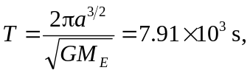

a little more than two hours. b) See Problem 12.74; 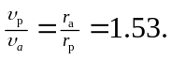c) The equation that represents conservation of energy (apart from a common factor of the mass of the spacecraft) is

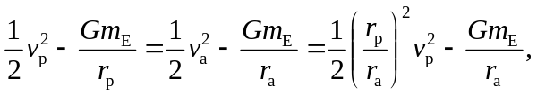

where conservation of angular momentum has been used to eliminate 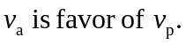
Solving for 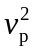 and simplifying,

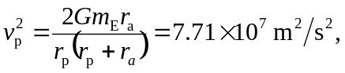

from which d) The escape speed for a given distance is 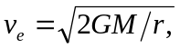 and so the difference between escape speed and 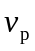 is, after some algebra,

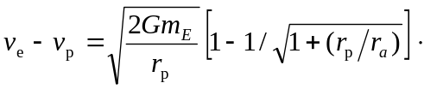

Using the given values for the radii gives 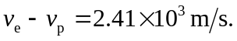 The similar calculation at apogee give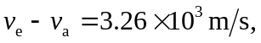 so it is more efficient to fire the rockets at perigee. Note that in the above, the escape speed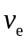is different at the two points,

